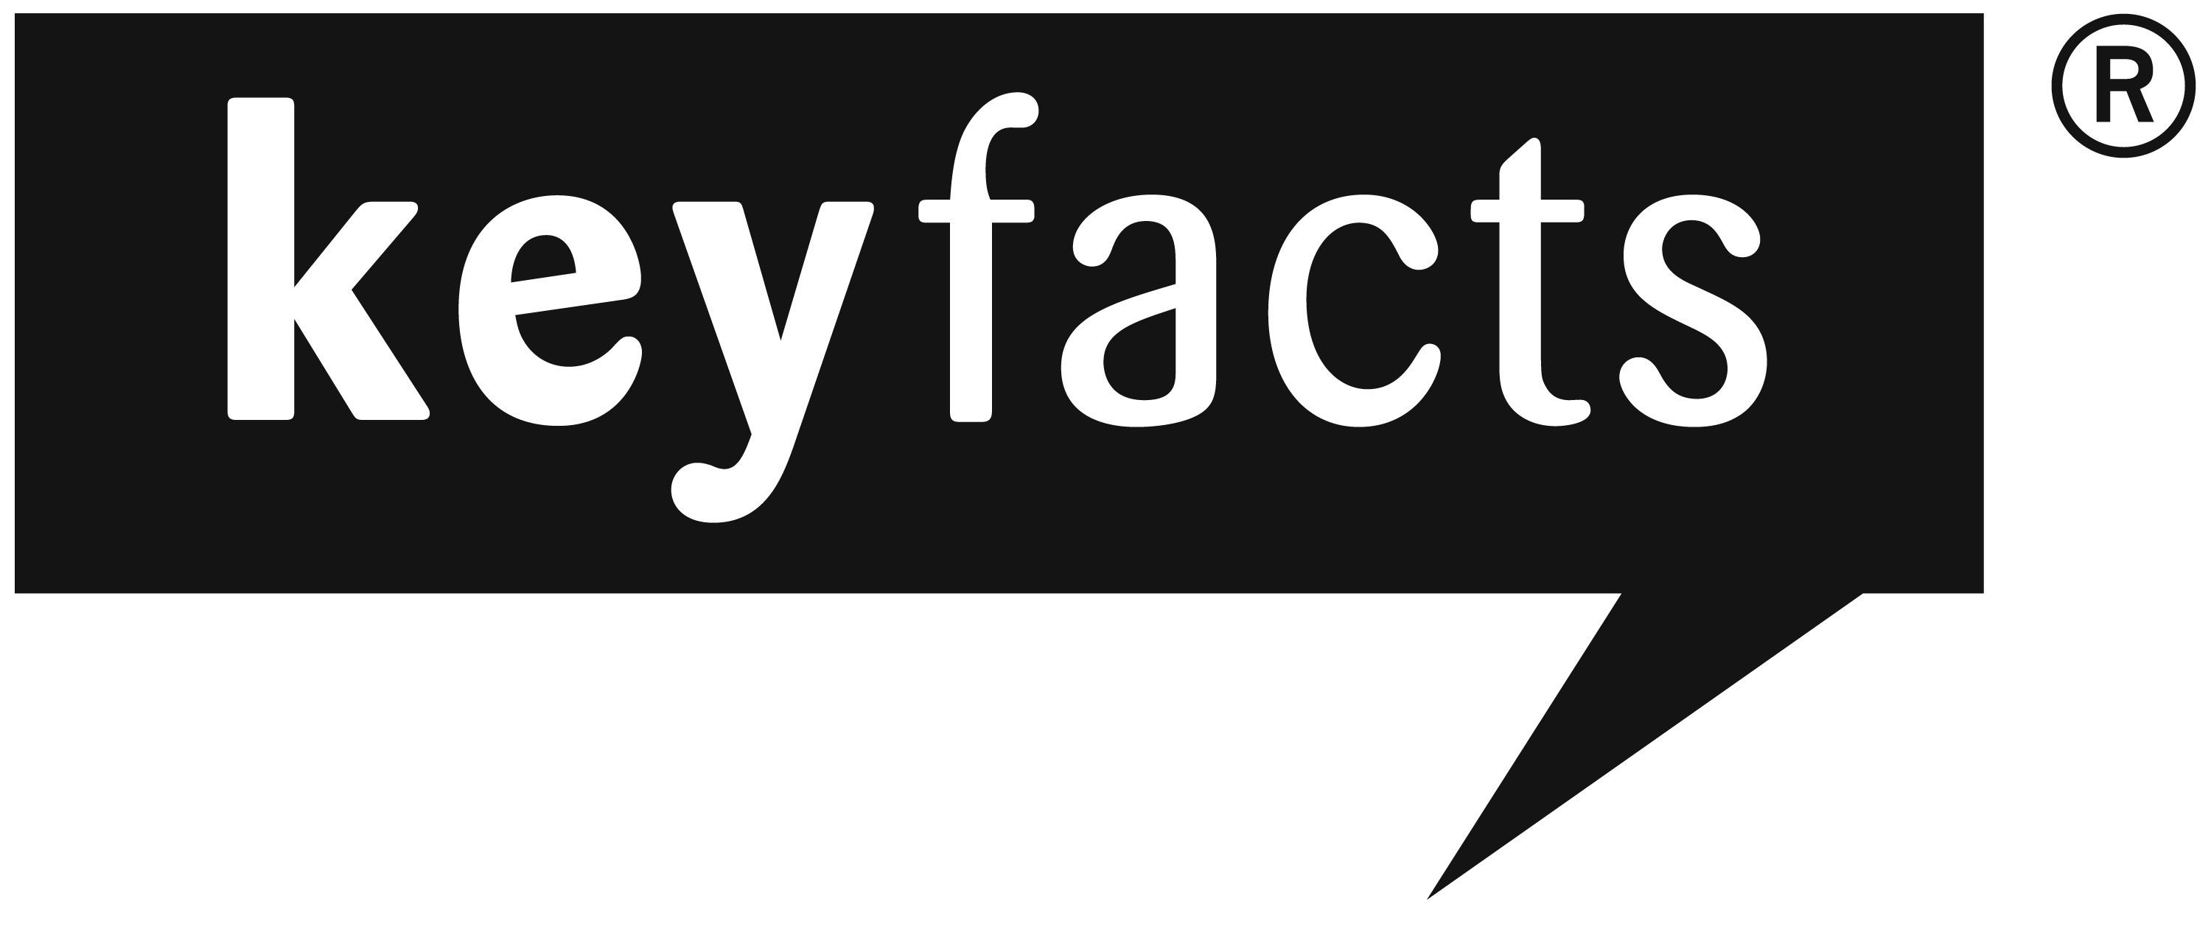 |  |  |  | about our services and costs
Howard Muir Associates LLP t/a Investment Companion  Westfield  Acomb Drive, Wylam  Northumberland NE41 8BD |  |  |  | 
- The Financial Services Authority (FSA)
The FSA is the independent watchdog that regulates financial services. This document is designed by the FSA to be given to consumers considering buying certain financial products. You need to read this important document. It explains the service you are being offered and how you will pay for it.
- Whose products do we offer?
Investment
☑ | We offer products from the whole market.
 | We only offer products from a limited number of companies.
 | We only offer products from a single group of companies
Insurance
☑ | We offer products from a range of insurers for Life Assurance, Critical Illness, Permanent Health Insurance, Private Medical Insurance.
 | We only offer products from a limited number of insurers.
 | We only offer products from a single insurer.
Mortgages
☑ | We offer mortgages from the whole market
 | We only offer mortgages from a limited number of lenders
 | We only offer mortgages from a single lender
- Which service will we provide you with?
Investment
☑ | We will advise and make a recommendation for you after we have assessed your needs
 | You will not receive advice or a recommendation from us. We may ask some questions to narrow down the selection of products that we will provide details on. You will then need to make your own choice about how to proceed.
We will provide basic advice on a limited range of stakeholder products and in order to do this we will ask some questions about your income, savings and other circumstances but we will not:
- Conduct a full assessment of your needs
- Offer advice on whether a non stakeholder product may be more suitable
Insurance
☑ | We will advise and make a recommendation for you after we have assessed your needs.
 | You will not receive advice or a recommendation from us. We may ask some questions to narrow down the selection of products that we will provide details on. You will then need to make your own choice about how to proceed.
Mortgages
☑ | We will advise and make a recommendation for you after we have assessed your needs.
 | You will not receive advice or a recommendation from us. We may ask some questions to narrow down the selection of products that we will provide details on. You will then need to make your own choice about how to proceed.
- What will you have to pay us for our services?
Investment
You will pay for our services on the basis of either a fee, or by commission through product charges or by a combination of both. We will discuss your payment options with you and answer any questions you have. We will not charge you until we have agreed with you how we are to be paid.
Paying by Fee
Whether you buy a product or not, you will pay us a fee for our advice and services, which will become payable on completion of our work. If we also receive commission from the product provider when you buy a product, we will pass on the full value of that commission to you in one or more ways. For example, we could reduce our fee, or reduce your product charges, or increase your investment amount or refund the commission to you.

Our typical charges are:

Principal/Director/Partner £180 per hour
Paraplanner £90 per hour
Administrator £60 per hour

We will confirm the rate we will charge in writing before beginning work and we will tell you if you have to pay VAT. You may ask us for an estimate of how much in total we might charge. You may also ask us not to exceed a given amount without checking with you first.

Paying by Commission (through product charges)
If you buy a financial product, we will normally receive commission on the sale from the product provider. Although you pay nothing to us up front, that does not mean our service is free. You still pay us indirectly through product charges. Product charges pay for the product providers own costs and any commission. These charges reduce the amount left for investment. If you buy direct, the product charges could be the same as when buying through an adviser, or they could be higher or lower.

The amount of commission we receive will vary depending on the amount you invest and (sometimes) how long you invest or your age.

For example,

- If you invest £10,000 in a Unit Trust, we would receive commission of 3% of the amount invested (£300) and 1% of the value of the fund (roughly £100 ) every year.
- If you pay £100 a month into a personal pension (with a term of 25 years) then we would receive commission of £328 initially.
- If you invest £10,000 into a personal pension, then we would receive commission of 3% (£300).

We will tell you how much the commission will be before you complete an investment, but you may ask for this information earlier.

Paying by a combination of fee and commission (through product charges)
We will charge you a combination of fee and commission. The fee will not exceed the rates shown in this document. We will agree the rate we will charge before beginning work and we will tell you if you have to pay VAT. The fee will become payable on completion of our work. You may ask us for an estimate of how much in total we might charge. You may also ask us not to exceed a given amount without checking with you first. We will tell you how much the commission will be before you complete an investment, but you may ask us for this information earlier

We will charge you a combination of fees and commission. The actual amounts will depend on the service provided to you but will be in line with the arrangements set out in the sections headed ‘Paying by fee’ and ‘Paying by commission (through product charges)’.
Insurance
 |  |  | A fee.
☑ |  |  | No Fee
You will receive a quotation which will tell you about any other fees relating to any particular insurance policy.
Mortgages
 |  | No fee. We will be paid by commission from the lender.
☑ |  | A fee of £350 payable on completion of the mortgage. We will also be paid commission from the lender.
You will receive a key facts illustration when considering a particular mortgage, which will tell you about any fees relating to it.
Refund of fees
If we charge you a fee, and your mortgage does not go ahead, you will receive:
 |  | A full refund
☑ |  | No refund as no fee payable unless mortgage completes.
5. Who regulates us?
Howard Muir Associates LLP of Westfield, Acomb Drive, Wylam, NE41 8BD and is authorised and regulated by the Financial Services Authority. Our FSA number is 454052.

Our permitted business is advising on and arranging savings and investment products, pensions, regulated mortgage contracts and non-investment insurance contracts.

You can check this on the FSA’s Register by visiting the FSA’s Website www.fsa.gov/uk/register/ or by contacting the FSA on 0845 606 1234.

6. What to do if you have a complaint
If you wish to register a complaint, please contact us:
….in writing Write to the Compliance Officer, Howard Muir Associates LLP t/a Investment Companion, Westfield, Acomb Drive, Wylam, NE41 8BD
….by phone Telephone 01661 854121
If you cannot settle your complaint with us, you may be entitled to refer it to the Financial Ombudsman Service.
7. Are we covered by the Financial Services Compensation Scheme (FSCS)?
We are covered by the FSCS. You may be entitled to compensation from the scheme if we cannot meet our obligations. This depends on the type of business and the circumstances of the claim.
Investment
Most types of investment business are covered for 100% of the first £30,000 and 90% of the next £20,000 so the maximum compensation is £48,000.
Insurance
Insurance advising and arranging is covered for 100% of the first £2,000 and 90% of the remainder of the claim, without any upper limit.
Mortgages
Mortgage advising and arranging is covered for 100% of the first £30,000 and 90% of the next £20,000 so the maximum compensation is £48,000.
Further information about compensation scheme arrangements is available from the FSCS.

